**PF LAB #3 TASK**

**Name :** Muhammad Jawwad

**Section & Roll No. :** BCS 1K-0536

Task 1:

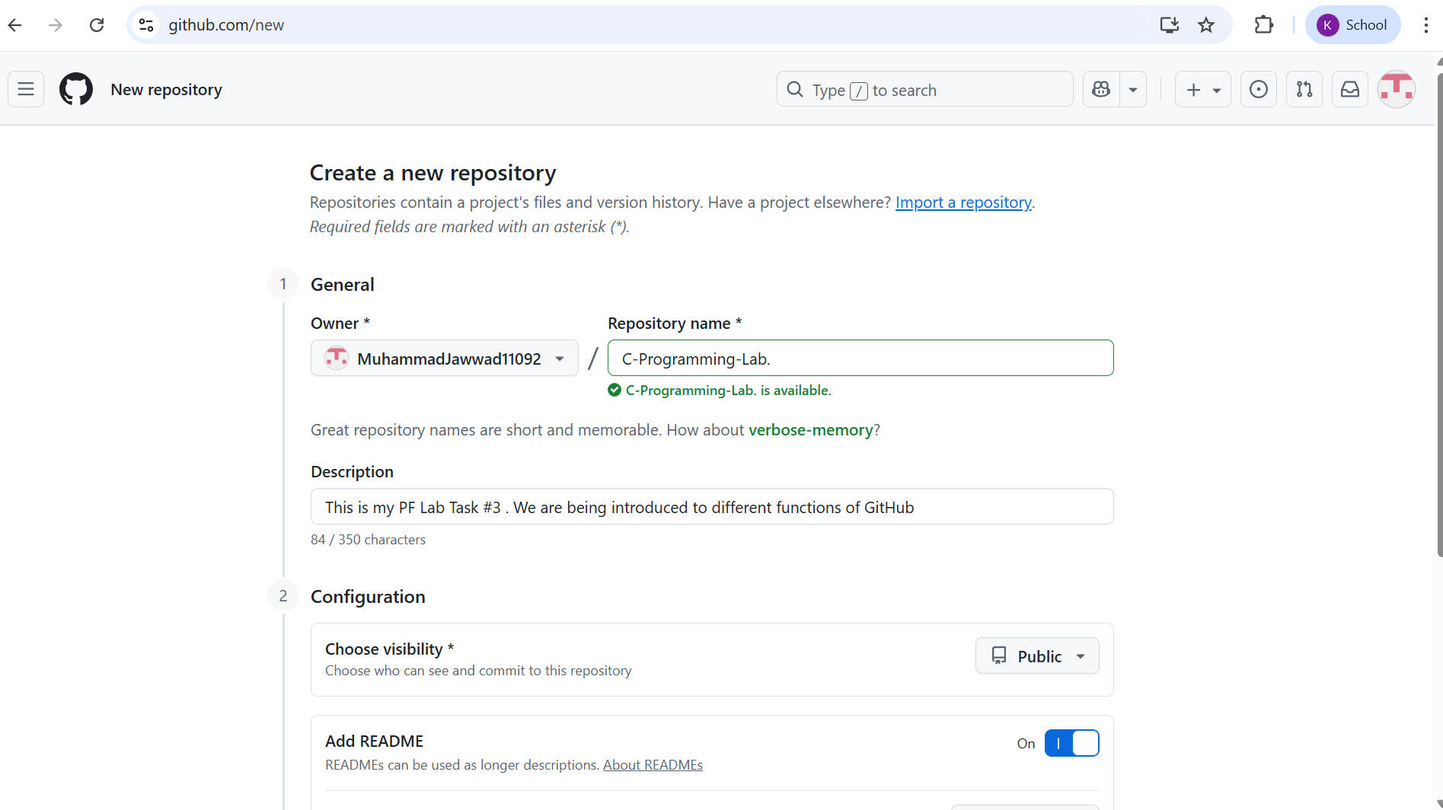

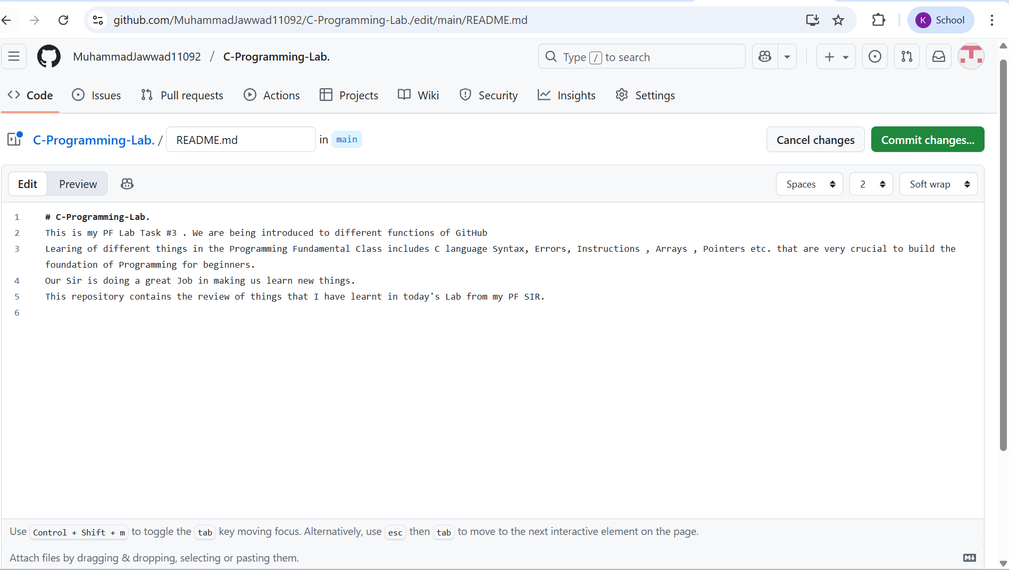

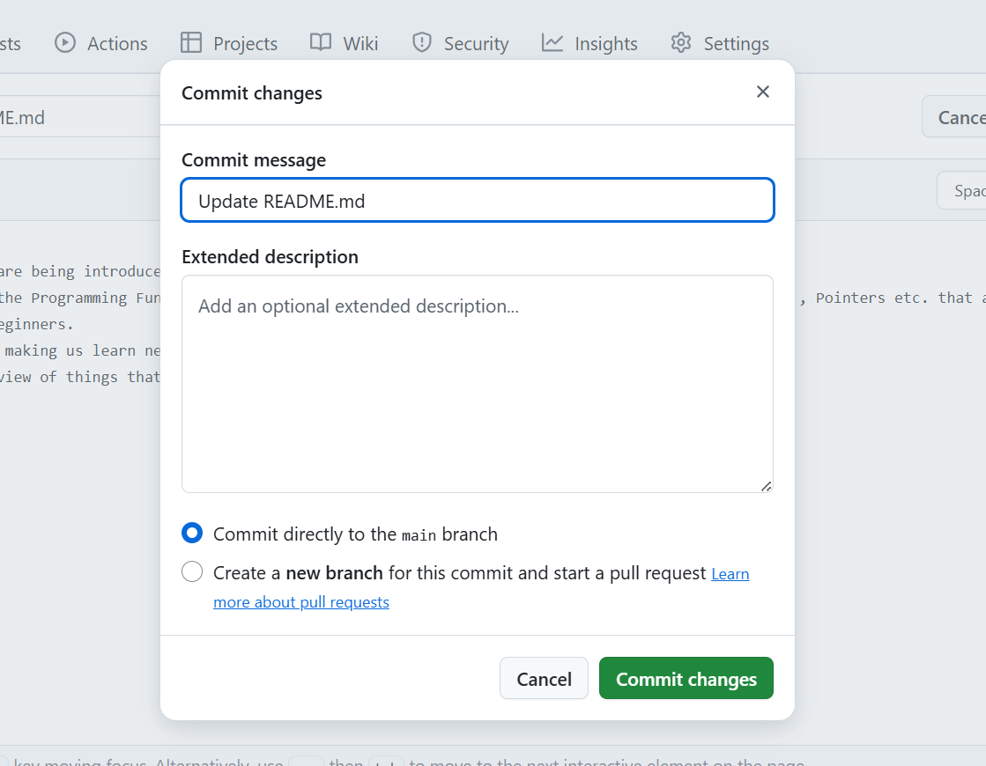

https://github.com/MuhammadJawwad11092/C-Programming-Lab.

Task 2 :

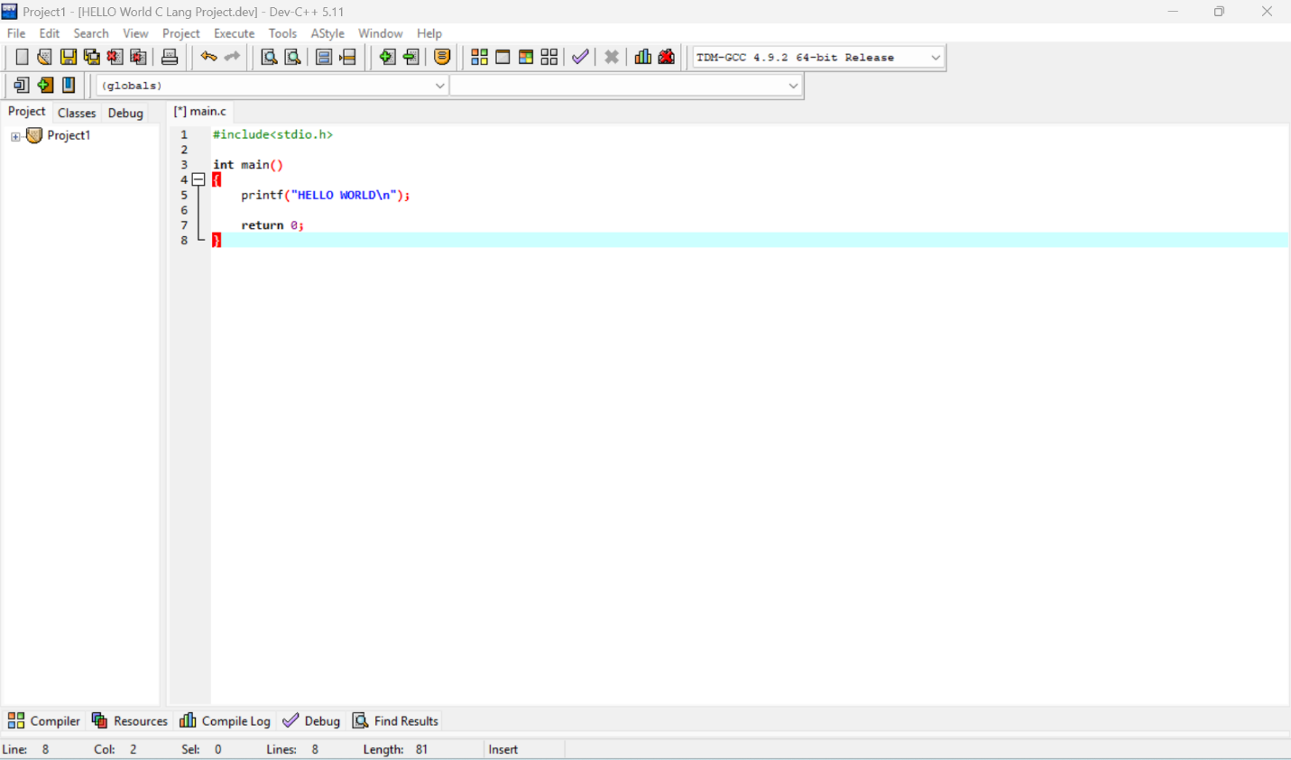

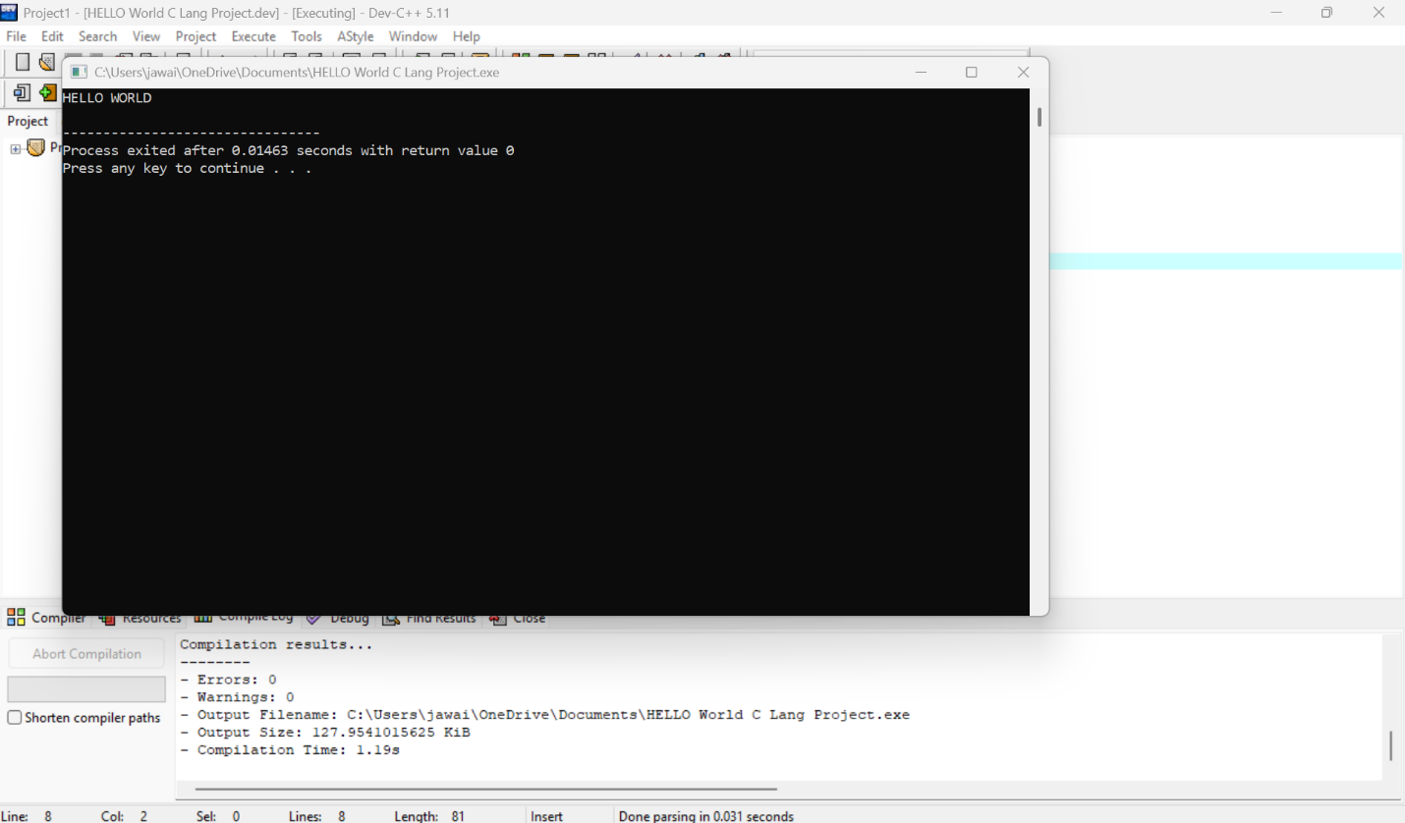

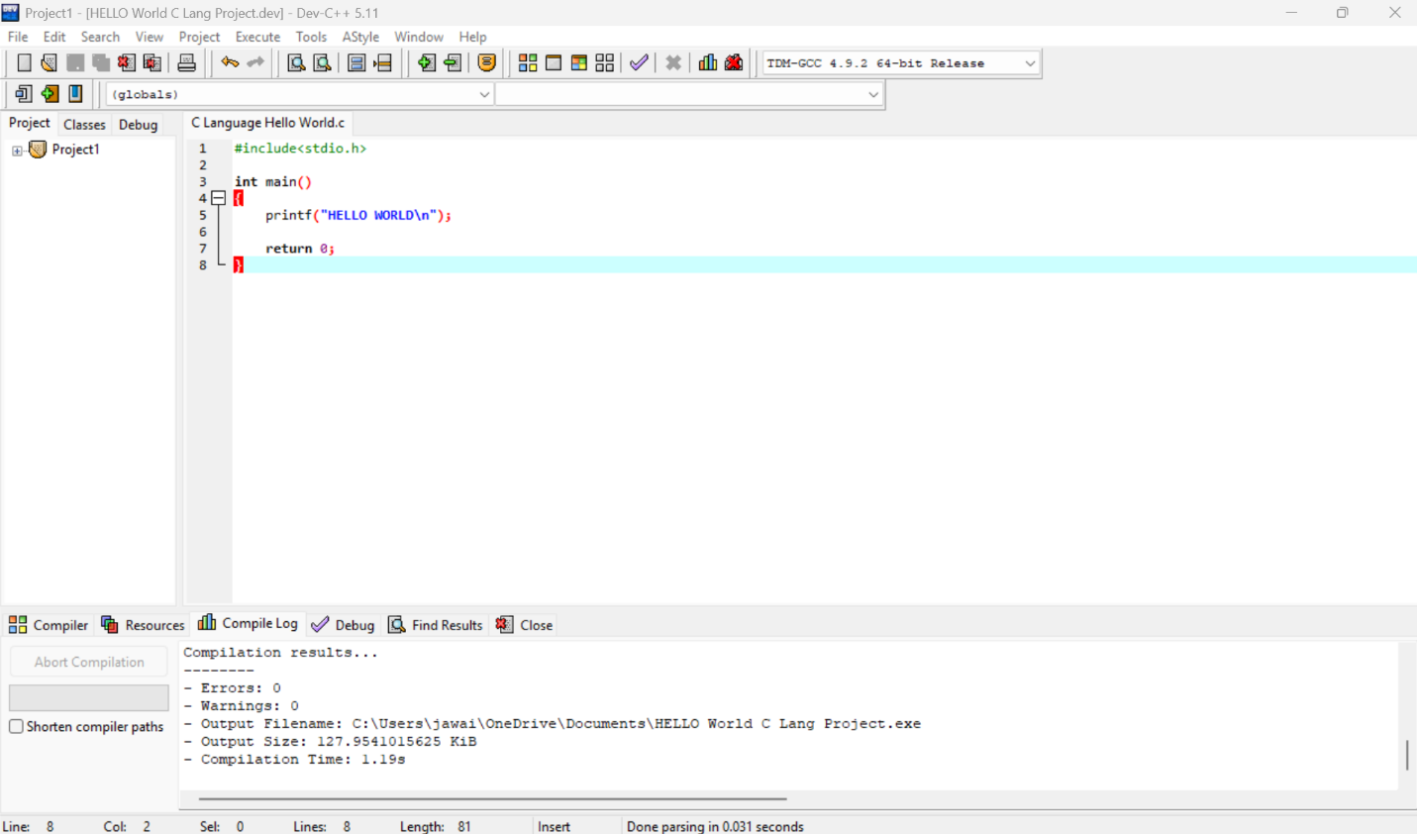

#include<stdio.h>

int main()

{

printf("HELLO WORLD\n");

return 0;

}

Task 3 :

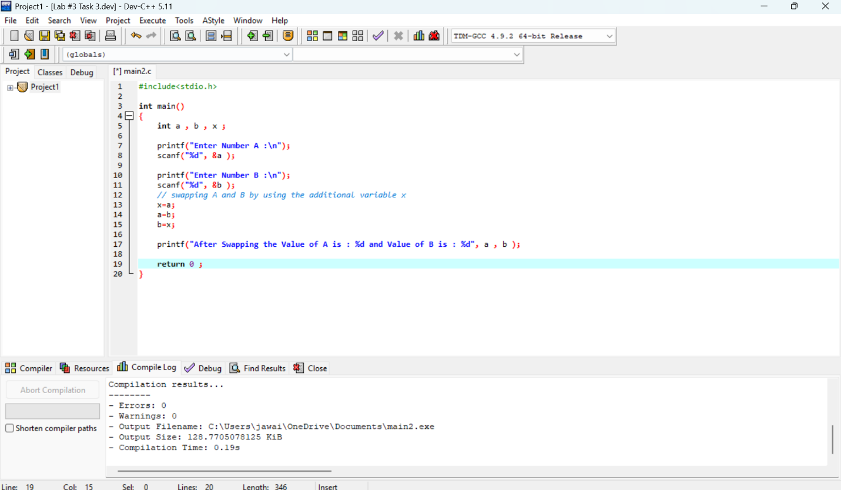

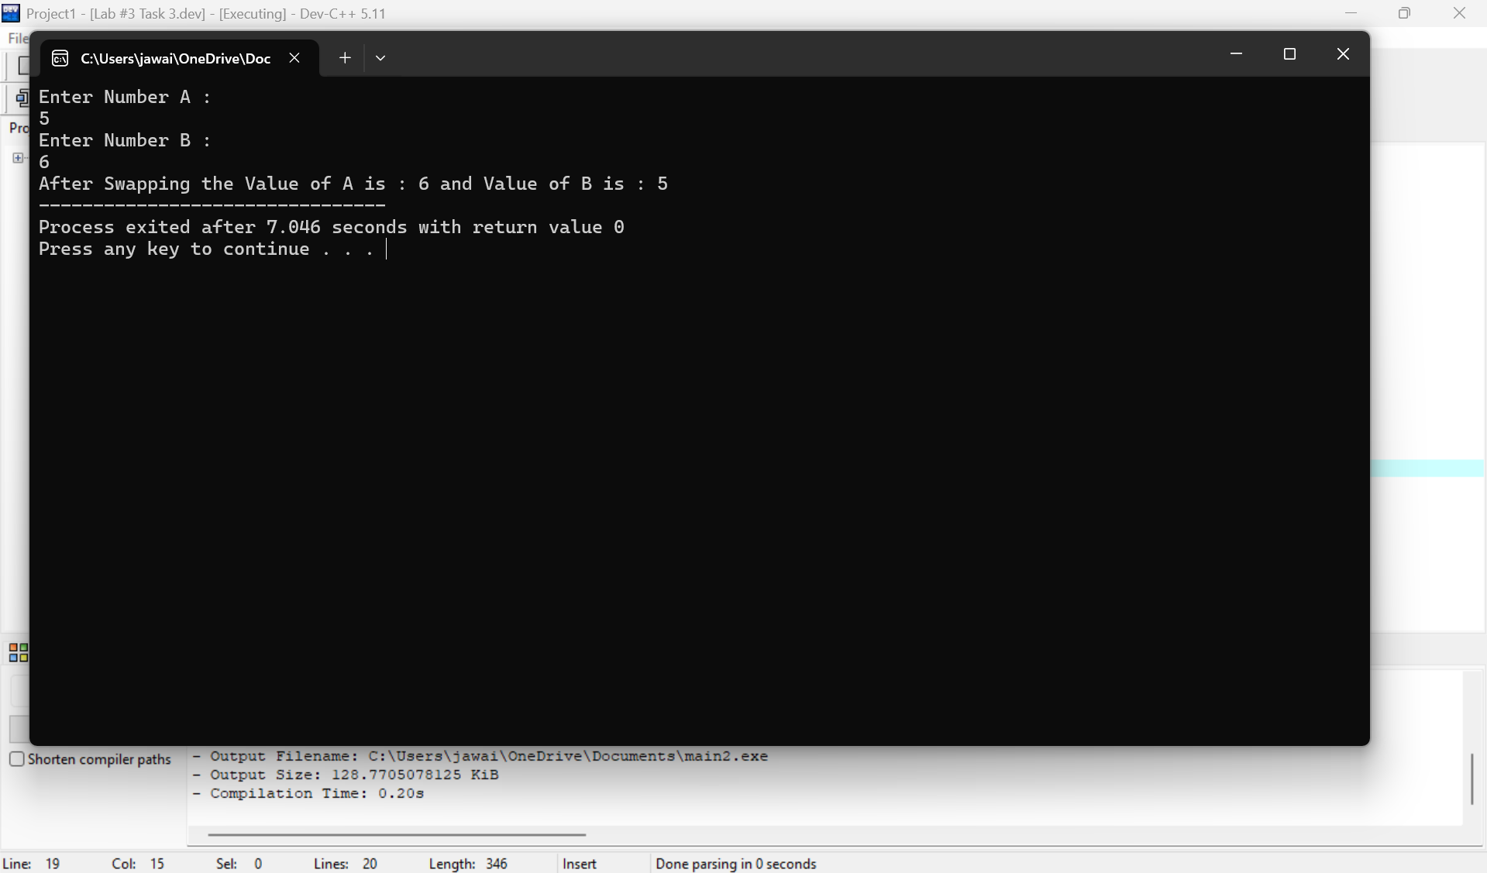

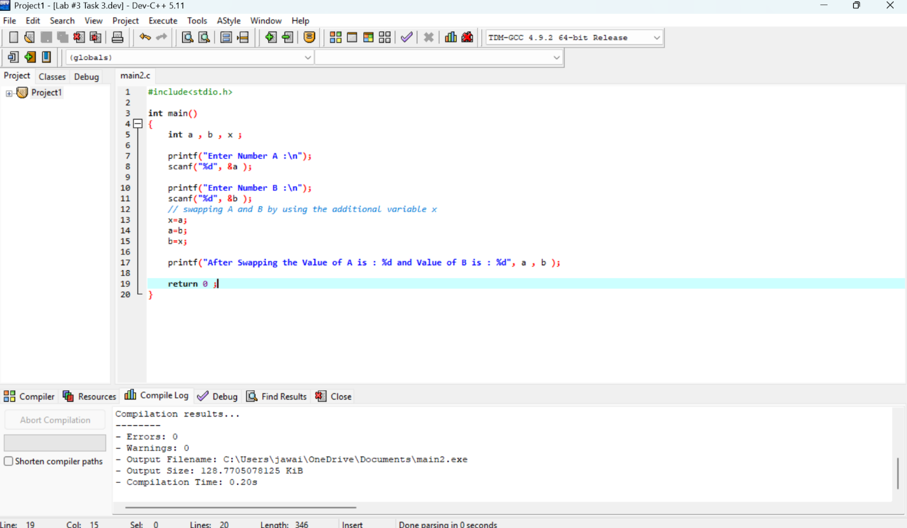

#include<stdio.h>

int main()

{

int a , b , x ;

printf("Enter Number A :\n");

scanf("%d", &a );

printf("Enter Number B :\n");

scanf("%d", &b );

// swapping A and B by using the additional variable x

x=a;

a=b;

b=x;

printf("After Swapping the Value of A is : %d and Value of B is : %d", a , b );

return 0 ;

}